Sequim School District

Department of Teaching and Learning
Career and Technical Education (CTE)
2016 - 2017

Spring Report

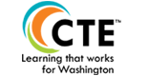

What Is Career and Technical Education
Today’s CTE programs are cutting-edge, rigorous instructional programs that prepare students for a wide range of high-wage, high-demand careers. CTE programs and activities serve students and families throughout Sequim School District facilities, community satellites, and businesses with an emphasis on college and career readiness through a comprehensive program supporting career awareness, exploration, planning, preparation, and transition to post-secondary education or training.
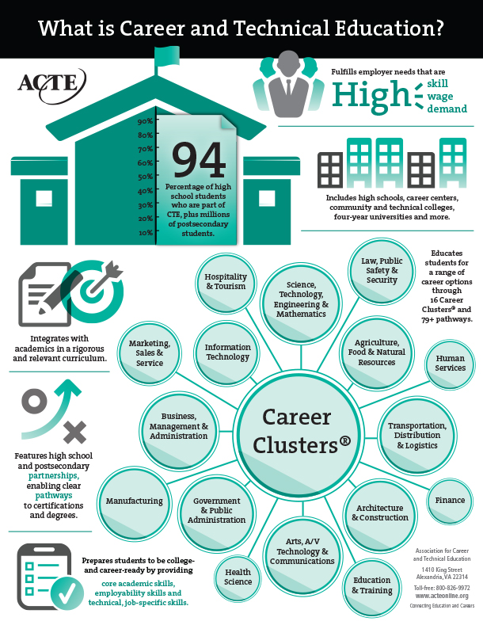

Sequim CTE Enrollment 2015 – 2016 in FTE
Career and Technical Education (CTE)
1. Grades 7-8 CTE Exploratory 24.89
2. Grades 9-12 High School CTE Exploratory 214.3
3. Grades 9 – 12 SOS Program CTE 3.6

Of the total enrolled HS Students (664) there are 341 Males and 323 Females. Middle School 130 students 77 male and 53 female. SOS program 19 students, males 8 and females 11.
This is 813 total students in CTE. There are 47.6% female and 52.4% male.
*Our Goal is to reach the 50 – 50 Split.
Last year Sequim had 92 CTE Completers in our programs.
Community Partnerships
Armstrong Marine, Clallam Conservation District, Sequim Animal Hospital, Sequim Co-op, Les Schwab Tires, Feiro Marine Life Center, Navsea Keyport/PSNS & IMF (Naval Shipyard), Old Gardner Gardner Club, Maple View Farms, My Choices, Rotary, Sequim Sunrise Rotary, Elks, Ferguson, Frank Lemke, Peninsula Nursery, The Pumpkin Patch, Robin Hill Veterans Farm, P.A. Gun Club, Microsoft, and Peninsula College.

Work Based Learning
Currently there are 24 students earning Credits for their job. These students earn credits based on the hours they work. This is true on the job training.
New Course Offerings
Staff Assistant: 79 students
AP Computer Science Principals – 14 students
Interior Design – 2nd semester 17 students enrolled
Game Design – Middle school course – 20 enrolled this semester Next year beginning a second year game design course.
Advanced Welding – Aluminum Welding – 7 students Next year 22 signed up

What’s Happening
From Christy Ditlefsen (business department):

The Growl News Network (GNN) is back! This year's staff have been busy training and putting together a student-run weekly news broadcast. Students create all broadcast graphics, write script, film, and edit video footage to report to all high school students in lieu of the oral announcements read throughout the rest of the week by ASB. Possible segments include: What's Happening at SHS, Birthdays, Sports Report, Question of the Week, Weather Report, The Top 5, Foodies, Trivia, Student Spotlights, Staff Spotlights, Club Sportlights, a Community Event Connection, and everyone's favorite-bloopers! You can check it out on our YouTube channel "Sequim GNN".

A brand new class "Interior Design" is being offered second semester! Seventeen students are signed up to find out more information about this exciting career option! Course content provides opportunities for students to explore elements and principles of design; client and interior designer relationships; space and floor plannning; and furniture and accessory selection; along with much more! The culminating project includes creating a business and marketing plan for a design studio and working with an assigned client (SHS Staff) to design a space! I'm so excited!!!

This year at Sequim High School two classrooms are the recipients of last years Engineering Technology students hard work. Last year the students of Mr. Seabolt’s Engineering Technology class were challenged with building 20 metal classroom desks in just the last 8 days of the school year. Mr. Mahitka, the FFA instructor and Votech Director, and Mr. Seabolt were discussing the cost of new desks and decided that both classrooms needed good sturdy desks and could make them at a third of the cost of buying them. Pictured standing with the new desks is Adrian Klarich, one of the main welders on last year’s project. The students were taught how to mass produce a quality product in an assembly line process with a minimum timeline. After constructing the tables they were taken to Dog House Powder Coating and were sandblasted and clear coated, with a final cost of $110 per desk. Other students involved with the project were: Bailey Cauffman, Porter Funston, Benjamin Logan, Jacob Myers, Kasey Spencer, and Michelle Wilson.FBLA members participated in three conferences this year, starting with the Peninsula Fall Leadership Conference at the LeMay Automobile Museum of America in Tacoma, then the Puget Sound Region Winter Conference at Pacific Lutheran University, and culminating with the Washington State Business Leadership Conference in Spokane. The following students represented Sequim at the state conference; Tolin Simpson in Computer Game and Simulation Programming, and Morgana Fergusson and Mikayla Ewing in Speechification.
Cooking class continues to help out different events, starting with the open house. They cook for Mr. Langston’s classified luncheon, make treats for ASB events, including the upcoming teacher appreciation. Two times a year they do the dinner for the CTE advisory board and will be doing the dessert for the FFA banquet in June. It continues to be a very full and popular class….
Photography:

We had a great field trip to Marymere Falls with our advanced photography class. We took some photos at Lake Crescent Lodge for architecture and landscape and then worked our way up Barnes Creek. Along the way we took fall foliage photos and some slow shutter water shots. We finished at the falls and again worked with slow shutter and landscape shots. This trip gave us the chance to work in the field on perfecting some of the techniques used to produce certain shots, working with aperture, shutter speed and ISO. The weather was perfect and the 5 students that went did well. It will also give them some photos to choose from for the SkillsUSA contest in January.

FFA
FFA had a Fantastic Summer with many great opportunities at Fairs for our students. Clallam fair had 14 members participate in the showmanship and auction. Great learning opportunities are found in this arena. At the Puyallup State Fair 5 members took 20 animals and participated well. The livestock Judging team took 1st out of 45 teams in the judging contest having 3 members place in the top 7 individual. They also won the chapter herds in the cattle arena having the top 5 head of all FFA members present. Hayden Williams had the Supreme Bull which is the best Bull present and Jorden Reed won fit and Show in the Novice arena
We have 2 members that will be earning their American Degree this Month in Indianapolis Indiana. 5 members are looking to go. We have been doing the drive through dinners to support this trip.

Grant Funding:

CTE is actively researching grants to help fund our outstanding programs:
We currently are working on:
Computer Science Grant
Perkins Grant
Clallam Conservation Grant
Nontraditional Grant
High Demand Grant
Robotics Grant

